Enterprise Class Mixed-Use SSD with Power Loss Protection

[Watch Video](https://www.kingston.com/en/video/play?videoId=aFPTYaO7FcbwNEyqT9tw6GB_ouFLkT_t-kSUTirbqCgn1VQJk_VFBCkGHYg-jENzWVwZD-wtuwZQsxveFai4YQ2&start=0&autoPlay=False&chromeless=False&captionOption=No)

DC600M

* [Intro](https://www.kingston.com/en/ssd/dc600m-data-center-solid-state-drive#product-features)
* [Specifications](https://www.kingston.com/en/ssd/dc600m-data-center-solid-state-drive#specifications)
* [Resources](https://www.kingston.com/en/ssd/dc600m-data-center-solid-state-drive#links)
* [Datasheet](https://www.kingston.com/datasheets/sedc600m_us.pdf)

[**Buy**](https://www.kingston.com/en/ssd/dc600m-data-center-solid-state-drive#atc)

DC600M Series 2.5” SATA Enterprise SSD6Gbps SATA 3.0 Storage for Mixed-Use Server Workloads

Kingston’s DC600M and DC600ME SSDs are 4th generation data center SATA 3.0, 6Gbps SSDs utilizing 3D TLC NAND intended for “mixed use” server workloads. Both are well suited for a wide variety of server applications and include on-board power loss protection via hold-up capacitors. DC600M and DC600ME are designed to protect data against unexpected power failure and to ensure the drive will successfully re-initialize on the next power-up of the system. Designed to deliver low latency and IO consistency for system integrators, hyperscale data centers, and cloud service providers.  
  
DC600ME features AES 256-bit encryption and supports TCG OPAL 2.0 security standards.

Capacities available from 480GB-7.68TB1 to meet your data storage requirements.

* Designed for data center environments
* Hardware-based power loss protection
* Latency and IOPS consistency
* AES 256-bit Encryption with DC600ME
* Capacities up to 7.68TB1

Key Features



Designed for data center environments

Optimized to meet the high demands of Server RAID applications with low latency and IO consistency as the key design criteria.



Hardware-based PLP

Power loss capacitors to protect user data against unexpected power loss and enhance performance.

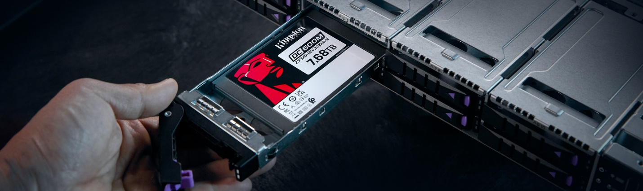

Delivers excellent Quality of Service (QoS)2

Optimized performance predictability to hit Service-level agreements (SLAs).



AES 256-bit Encryption with DC600ME

Protect sensitive data with support for AES 256-bit hardware-based encryption and TCG Opal 2.0 security standards with DC600ME.

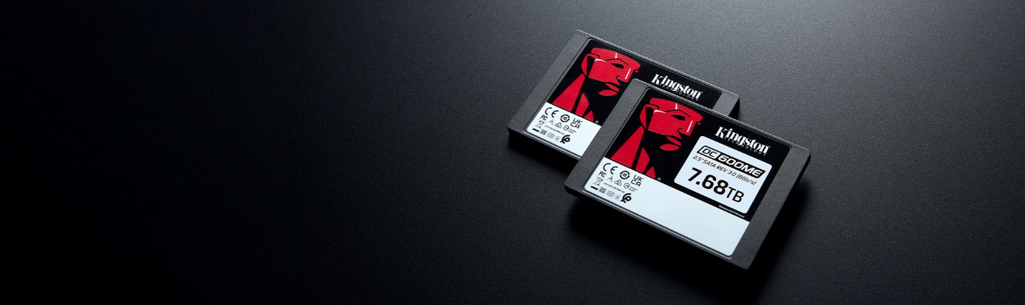

Capacities up to 7.68TB

Upgrade and manage storage with capacities up to 7.68TB.1

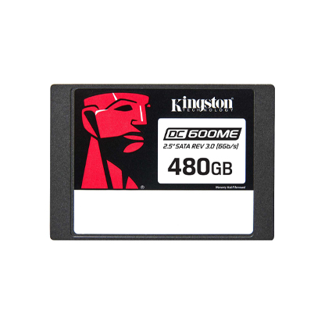

* [DC600ME 2.5” SATA Enterprise SSD - 480GB](javascript:void(0))
* [DC600ME 2.5” SATA Enterprise SSD - 480GB](javascript:void(0))
* [DC600ME 2.5” SATA Enterprise SSD - 480GB, in packaging](javascript:void(0))

Security Features

 AES 256 Bit

 None

Capacity

 480GB

 960GB

 1.92TB

 3.84TB

 7.68TB

* Part Number: SEDC600ME/480G
* Designed for Data Center Environments
* On-board Power Loss Protection (PLP)
* Consistent latency and IOPS, reliable QoS
* [Includes Acronis cloning software](https://www.kingston.com/cloning)
* TCG Opal 2.0, AES 256-bit encryption
* 560MB/s Read, 470MB/s Write

[Ask an SSD Expert](https://www.kingston.com/ssd/server/ask-an-expert)

[**Where to Buy**](https://www.kingston.com/en/wheretobuy)

Specifications

* **DC600M**
* **DC600ME**

|  |  |
| --- | --- |
| Form factor | 2.5 Inch |
| Interface | SATA Rev. 3.0 (6Gb/s) – with backwards compatibility to SATA Rev. 2.0 (3Gb/s) |
| Capacities1 | 480GB, 960GB, 1.92GB, 3.84GB, 7.68GB |
| NAND | 3D TLC |
| DRAM Cache | Yes |
| Sequential Read/Write | 480GB – 560MBs/470MBs 960GB – 560MBs/530MBs 1.92TB – 560MBs/530MBs 3.84TB – 560MBs/530MBs 7.68TB – 560MBs/530MBs |
| Steady State 4k Random Read/Write | 480GB – 94,000/41,000 IOPS 960GB – 94,000/65,000 IOPS 1.92TB – 94,000/78,000 IOPS 3.84TB – 94,000/59,000 IOPS 7.68TB – 94,000/34,000 IOPS |
| Quality of Service (Latency)3,4,5(99.999) | Read/Write 480GB – 180/110 uSec 960GB – 3.84TB – 200/300 uSec 7.68TB – 240/170 uSec |
| Typical Latency - Read/Write | <200 µs / <30 us3,4,5 |
| Hot-Plug Capable | Static and Dynamic Wear Leveling |
| Enterprise SMART tools | Reliability tracking, usage statistics, life remaining, wear leveling, temperature |
| Hardware-based Power Loss Protection | Yes |
| Endurance (TBW)6 | 480GB – 876TB, 1 DWPD (5 years), 1.66 DWPD (3 years) 960GB – 1752TB, 1 DWPD (5 years), 1.66 DWPD (3 years) 1.92TB – 3504TB, 1 DWPD (5 years), 1.66 DWPD (3 years) 3.84TB – 7008TB, 1 DWPD (5 years), 1.66 DWPD (3 years) 7.68TB – 14016TB, 1 DWPD (5 years), 1.66 DWPD (3 years) |
| Power Consumption | Idle: 1.30W Average: 1.45W Max Read: 1.6W Max Write: 3.6W |
| Storage temperature | -40°C ~ 85°C |
| Operating temperature | 0°C ~ 70°C |
| Dimensions | 69.9mm x 100mm x 7mm |
| Weight | 92.34g |
| Vibration operating | 2.17G Peak (7–800Hz) |
| Vibration non-operating | 20G Peak (10–2000Hz) |
| MTBF | 2 million hours |
| UBER | ≤10 -17 |
| Warranty/support | Limited 5-year warranty with free technical support7 |